nskVenue 1.0.0

Detailed Functional Design

2021-07-27

Contents

1 REVISION HISTORY 2

2 PURPOSE 3

3 Description 3

4 CONCEPTS 3

5 PERSISTENCE LAYER 3

6 DATABASE SCHEMA 3

7 CONCEPTS 4

7.1 VENUE INFORMATION 4

7.1.1 VenueRec 4

7.1.2 StudioRec 4

7.2 ACTIONS 5

7.2.1 ON VENUES 5

7.2.2 ON STUDIOS 7

# REVISION HISTORY

|  |  |  |  |
| --- | --- | --- | --- |
| Date | Version | Description | Author |
| 2021/07/27 | 1.0 | Initial version of the document | Paulo Márquez |
|  |  |  |  |
|  |  |  |  |
|  |  |  |  |
|  |  |  |  |
|  |  |  |  |

# PURPOSE

Athletic facilities, clubs and groups of the same interest will most likely need a gathering spot, be it a closed room, open plan areas or outdoors to meet and develop the activities agreed upon.

Venues is the microservice that keeps the description and capacities of each of those spaces.

# Description

nskVenue is the Venue management service for the KINESIK platform.

# CONCEPTS

|  |  |
| --- | --- |
| **VENUE** | Physical building where a Venue is located. |
| **STUDIO** | Room within the venue. |
| **ACCOUNT** | A KINESIK account can have one or more associated venues. |

# PERSISTENCE LAYER

MySQL is the DBMS of choice; SQL is the implementation. The structure of the venue data makes them ideal for a JSON and Collections approach, but lack of documentation made it too slow to implement. In a future release we will be implementing it.

# DATABASE SCHEMA

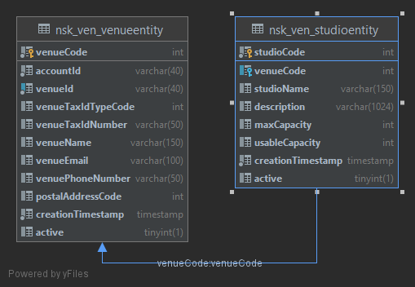

# CONCEPTS

## VENUE INFORMATION

The information we are keeping about a Venue is.

### VenueRec

int venueCode;

String venueId;

int accountCode;

String venueName;

String venueEmail;

String venuePhoneNumber;

LocalDateTime creationTimestamp;

List<StudioRec> studios;

boolean active;

Since a Venue can have one or more Studios, we also need the information about them.

### StudioRec

int studioCode;

int venueCode;

String studioName;

String description;

int maxCapacity;

int usableCapacity;

LocalDateTime creationTimestamp;

boolean active;

## API

### ON VENUES

##### Create Venue

Endpoint that creates a new Venue.

**Method:** POST

**Endpoint:** /venuesAPI/1.0/venue/

**Parameters**: VenueRec venue: The required data to create the venue.

**Returns**: void

**Headers**: Location = {Venue Resource Location}

**Status Codes**:

201: Created.

400: Could not create the Studio with the supplied data.

500: Internal Server Error.

##### Retrieve Venues

Endpoint to retrieve all Venues within a list of Ids.

##### Retrieve Venue

Retrieves a single Venue by Id

**Method:** GET

**Endpoint:** /venuesAPI/1.0/venue/{venueId}

**Parameters**: venueId: The UUID that represents the venue.

**Returns**: VenueRec

**Headers**: none

**Status Codes**:

200: OK

404: Venue not found

##### Search for Venue

Retrieves zero or more Venues by any of a number of possible search criteria.

##### Delete Studio from Venue

Deletes a Studio from a Venue.

**Method:** PATCH

**Endpoint:** /venuesAPI/1.0/venue/studio/{studioCode}

**Parameters**: studioCode: code of the Studio to delete.

**Returns**: void

**Status Codes**:

204: No Content

404: Studio not found

##### Enable Venue

Mary

##### Disable Venue

Pepe

##### Delete Venue

Deletes a Venue.

**Method:** DELETE

**Endpoint:** /venuesAPI/1.0/venue/{venueId}

**Parameters**: studioCode: Id of the Venue to delete.

**Returns**: void

**Status Codes**:

204: No Content

404: Studio not found

### ON STUDIOS

##### Add Studio from Venue

Adds a Studio to a Venue

**Method:** PATCH

**Endpoint:** /venuesAPI/1.0/venue/{venueId}/studio

**Parameters**: venueId: The UUID that represents the venue.

**Returns**: void

**Headers**: Location = {Venue Resource Location}

**Status Codes**:

201: Created.

400: Could not create the Studio with the supplied data.

404: Venue not found.

500: Internal error when attempting the creation of the Studio.

##### Retrieve Studios

Endpoint to retrieve all Venues that belong to the current account.

##### Retrieve Studio

Retrieves a single Studio by Id.

##### Search for Studio

Retrieves zero or more Studios by any of a number of possible search criteria.

##### Update Studio

Updates the information related to a Studio.

##### Delete Studio from Venue

Deletes a Studio from a Venue.

**Method:** PATCH

**Endpoint:** /venuesAPI/1.0/venue/studio/{studioCode}

**Parameters**: studioCode: code of the Studio to delete.

**Returns**: void

**Status Codes**:

204: No Content

404: Studio not found

##### Enable Studio

Enables the usability of a Studio

##### Disable Studio

Disables a Studio from being used.